COMP9032 Project User Manual

Name:Ran Bai zID:5187292

- Wiring

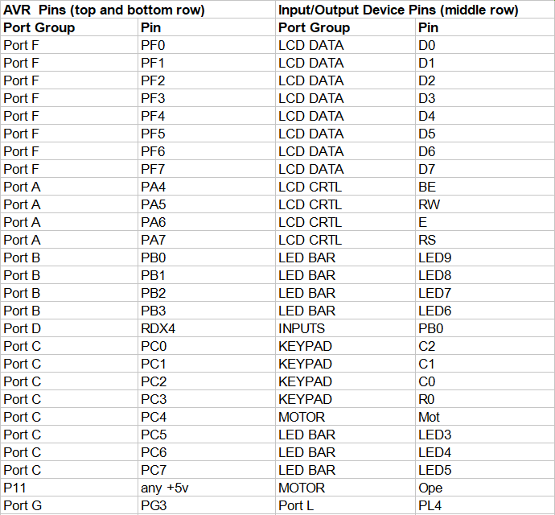

- Display Information
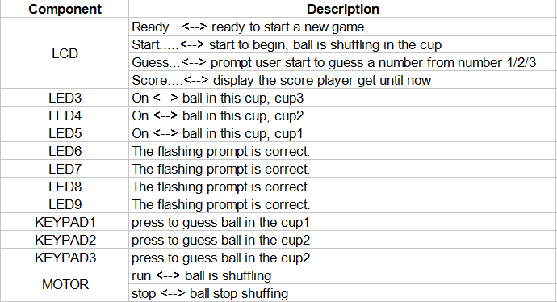

- Control Procedure
This project simulate the Cup and Ball game on the lab board. Cup and Ball Flash game a free online game were a ball is shuffled under three cups and players guess the position of the ball. Each correct guess scores a point. Player will lose a point because of the incorrectly guess.
At the beginning of the game, the player will see Ready.... on the LCD. This means the game is ready. When the player wants to start the game, press the green button PB0. The motor will then start, indicating that the ball has started switching in the cup. At this time, the LCD will also display Start..., and the three LEDs of the cup will show dim light. Next, the user should press the PB0 button again to stop the ball from switching in the cup and be represented by the motor stop. The user can use 1, 2, 3 on KEYPAD to guess which cup the ball is in when the LCD prompts GUESS.... If the guess is correct, the 4 LEDs will flash continuously, and the score will be displayed on the LCD plus 1. If the guess is wrong, the score displayed on the LCD will be decremented by 1. But whether it is correct or not, the position of the ball in the cup will be displayed in the LED representing the cup. The user can start the next round of the game by continuing to press PB0, but when the score is 0, the game will be restarted. Let’s start the game now! Wish you get a high score!

